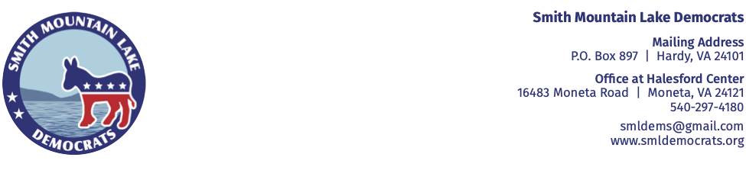
January 28, 2024 NEWS RELEASE
CONTACT: Lauren Hafner 727-482-7484

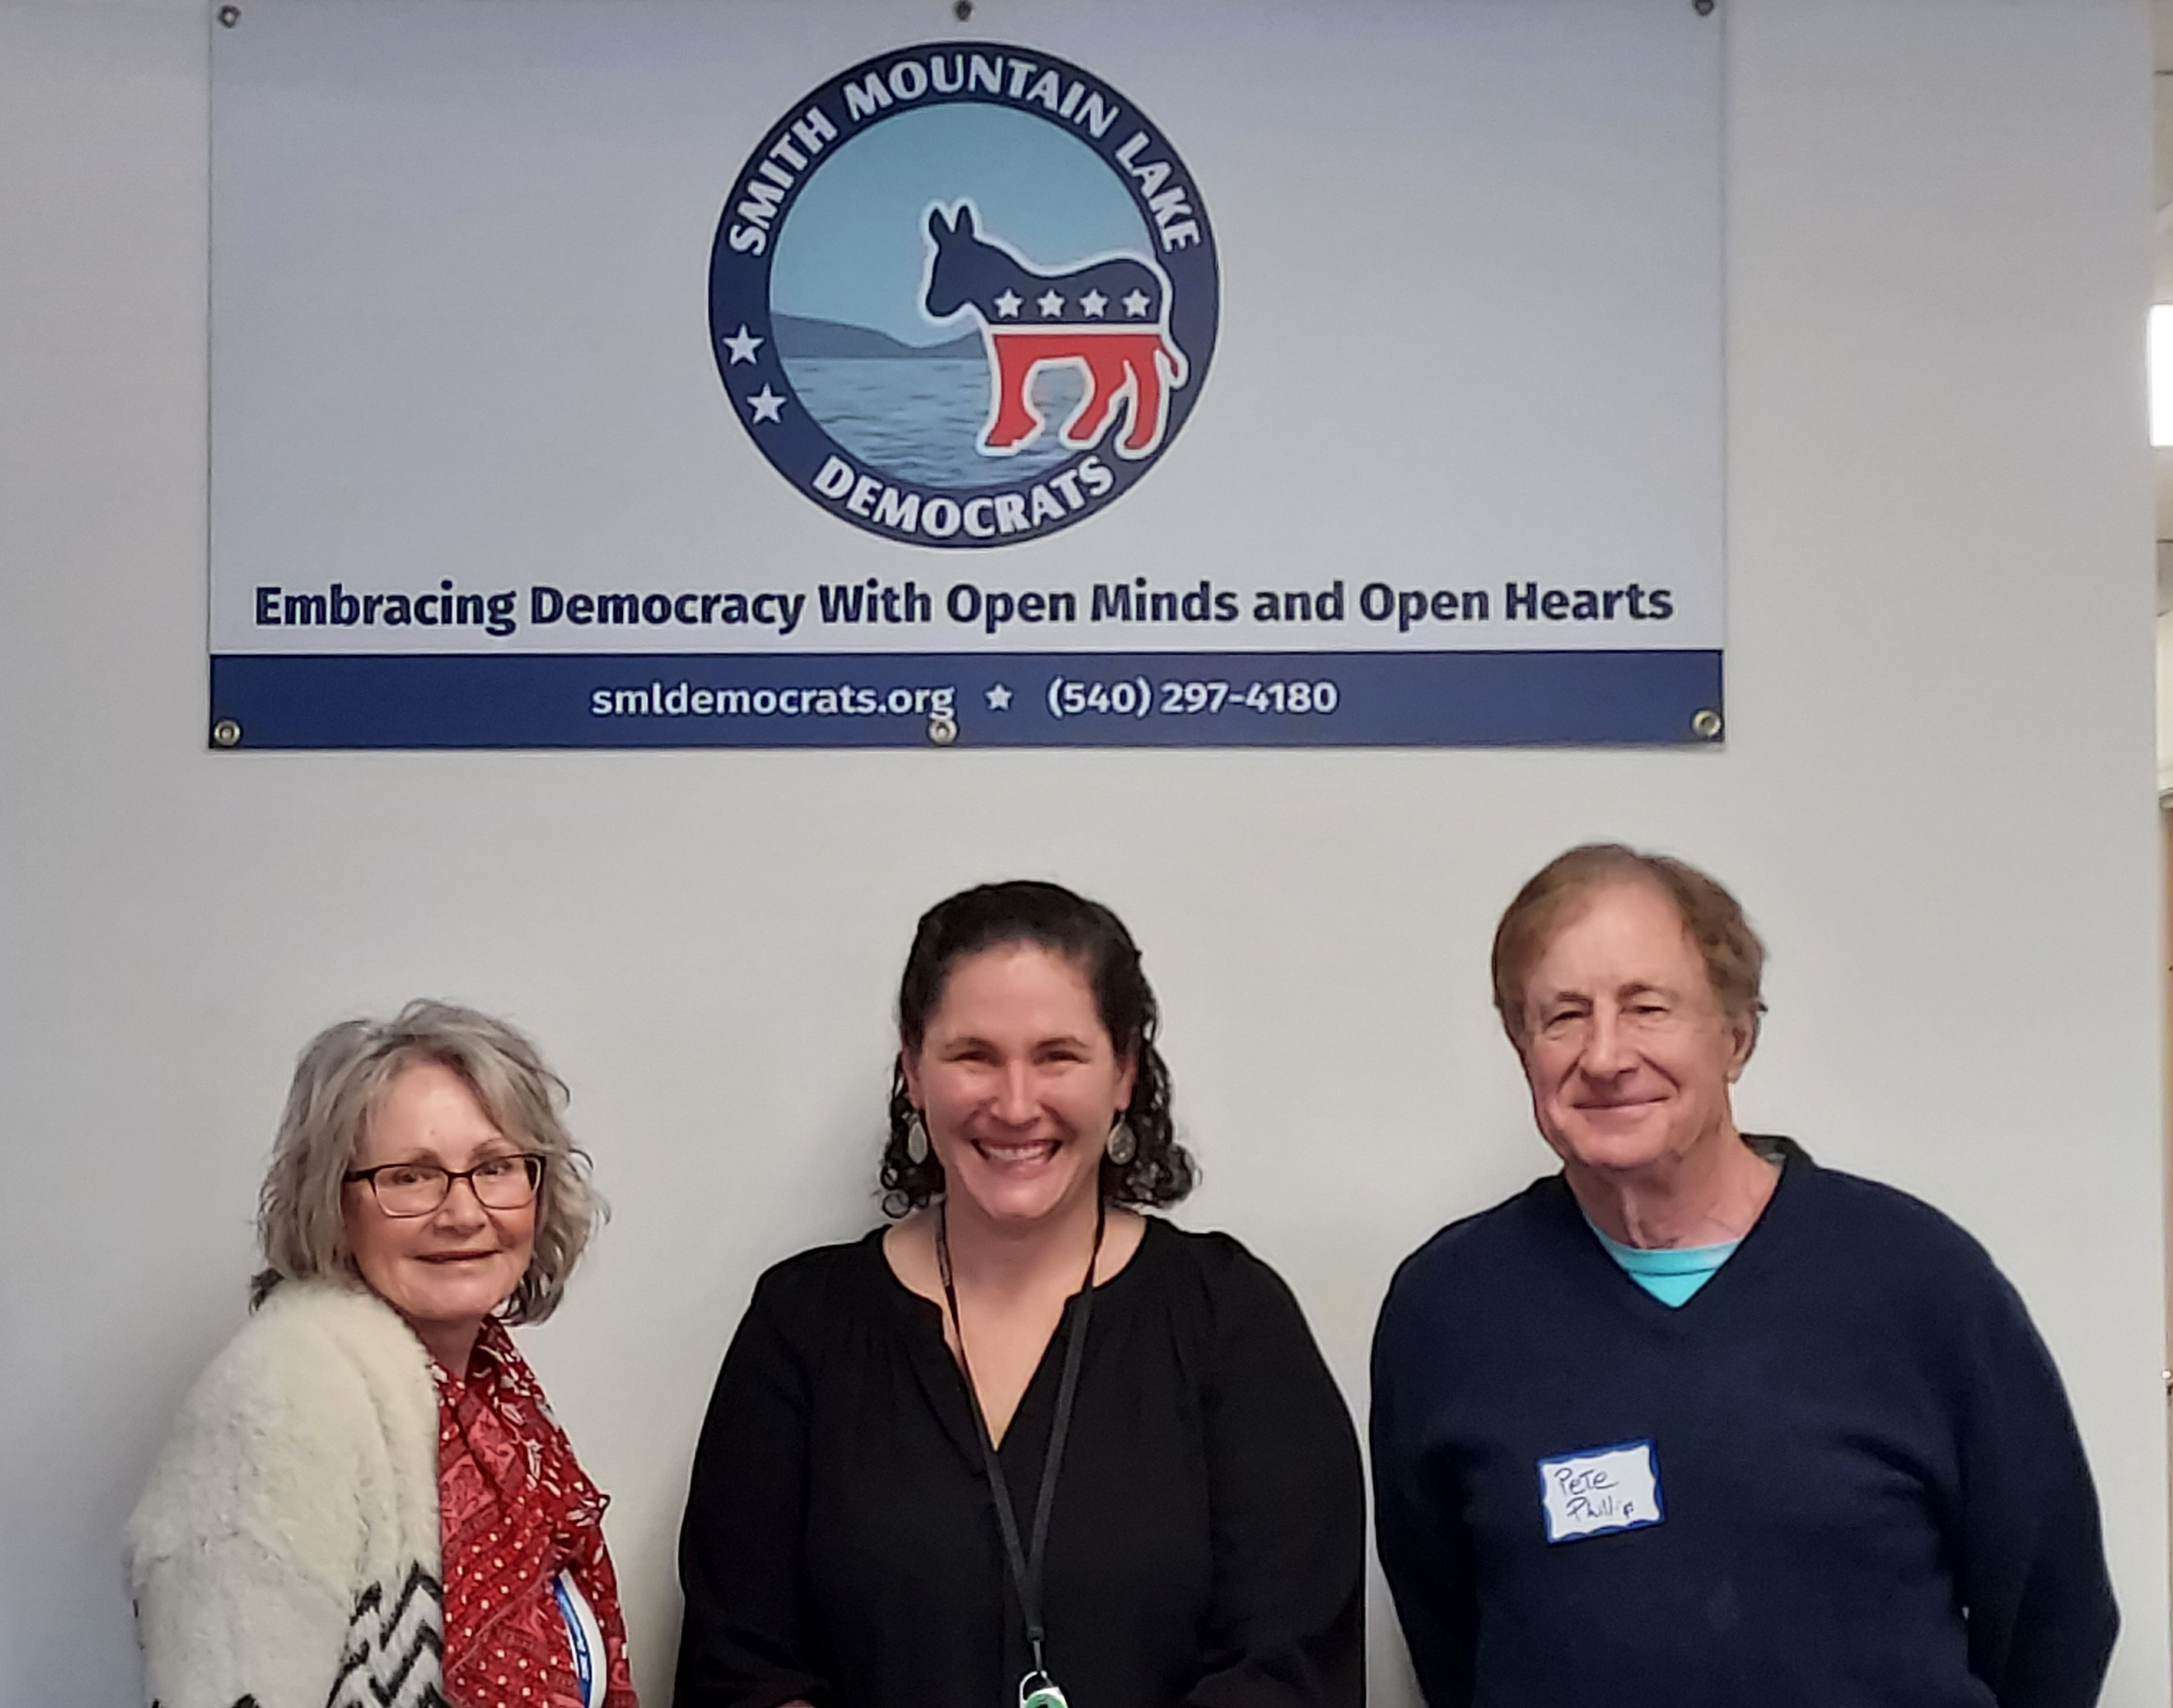
SML DEMOCRATS DISCUSS COUNTY’S FOSTER CARE SYSTEM
January 22, 2024 - The Smith Mountain Lake Democrats host Sara Calhoun M.A., Family Service Specialist at the Franklin County Department of Social Services at their general meeting. Ms. Calhoun has worked in various roles in the field of mental health and child welfare for nearly 20 years and, for the past nine, exclusively in foster care. Besides working so passionately in the field, Sara is a biological, adoptive, and foster parent of five children. Shown (l to r) are Cherie Lange, committee chair, Sara Calhoun, and Pete Phillip, club member.
###

