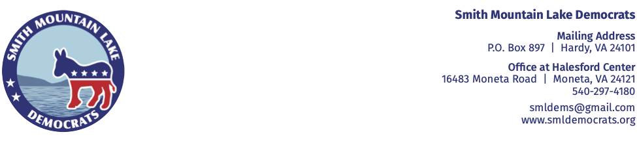
March 31, 2025 NEWS PHOTO
CONTACT: Lauren Hafner 727-482-7484

SML DEMOCRATS DONATE ITEMS TO BEDFORD AND FRANKLIN COUNTY

HUMANE SOCIETIES
March 20, 2025 - As part of their quarterly donation drives, the Smith Mountain Lake Democrats collected hundreds of items needed for the cats and dogs cared for by the Bedford and Franklin County Humane Societies. Pictured are Mary Gambolati and Marc Nevin, both members of the SML Democrats. Nevin also is Vice President of the Board of Directors of the Bedford County Humane Society. The Society has just broken ground on an adoption center and is raising funds for completion and furnishing the building. Contributions can be made by calling (540)586-6100.

###

