
April 30, 2025 NEWS PHOTO
CONTACT: Lauren Hafner 727-482-7484

SML DEMOCRATS MEET JOY POWERS,
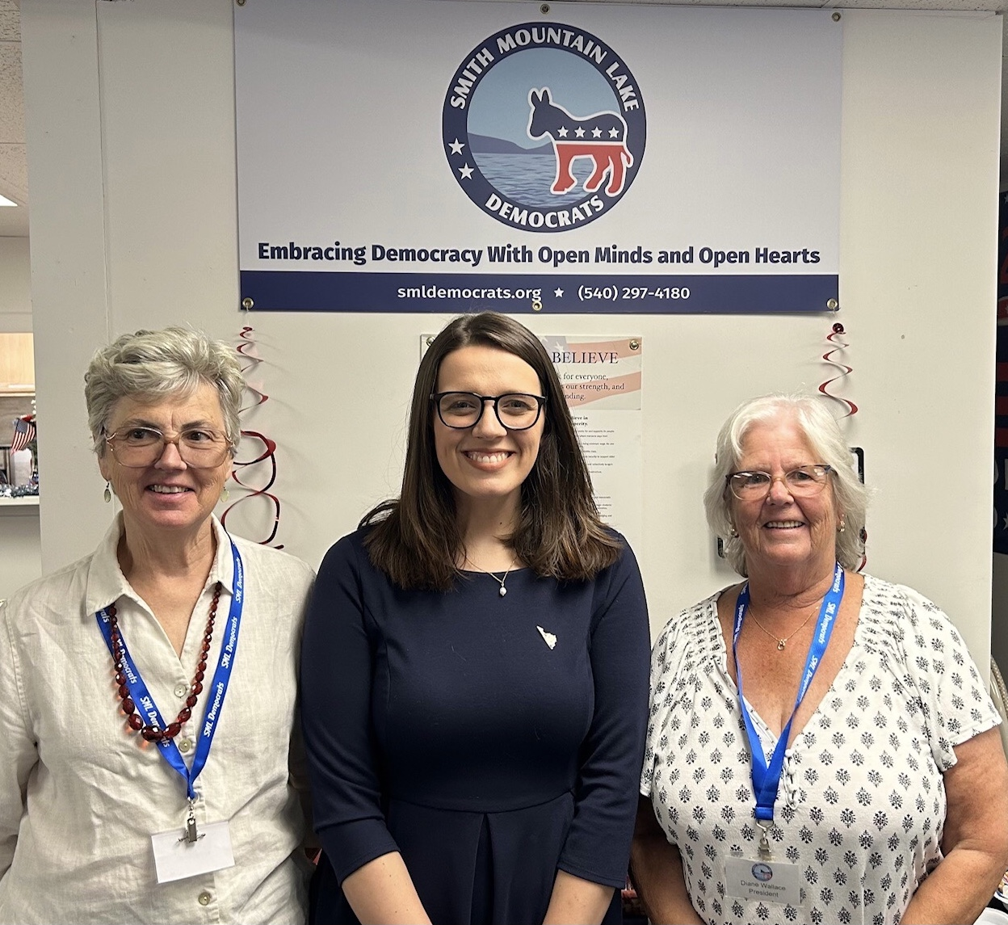
CANDIDATE FOR VA HOUSE OF DELEGATES
APRIL 30, 2025 - Smith Mountain Lake Democrats meet with Joy Powers who is running for Virginia House of Delegates District 51 which covers much of Bedford County. Ms Powers grew up in Bedford County and now runs her family’s 350 acre cattle farm with her husband and son she adopted through foster care. She will work for strong schools, good jobs, safer roads, support for first responders, farmers and veterans and to protect our rural way of life. Pictured (l to r) are: Karen Nuzzo, Chair Bedford County Democratic Committee, Joy Powers and Diane Wallace, President SML Democrats. For more information, see www.joyforva.com.

###

