
April 28, 2025 NEWS PHOTO
CONTACT: Lauren Hafner 727-482-7484

GLENDA WYNNES, CENTRE AT VITA ZEN
RELAXES WITH SML DEMOCRATS
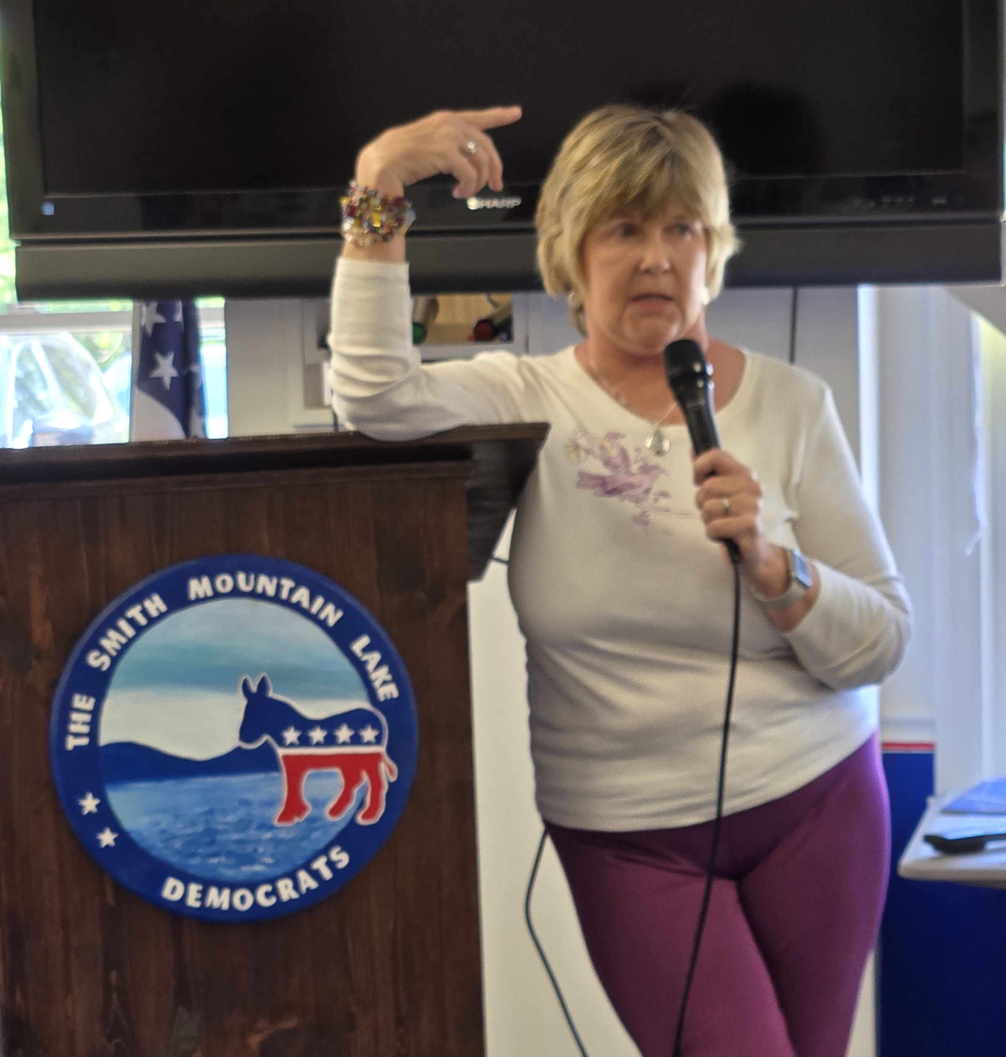
April 28, 2025 - The SML Democrats welcome Glenda Wynnes, owner of the Centre at Vita Zen in Westlake Corner.. Ms Wynnes is a registered nurse certified to teach yoga since 2013. She is the founder of “Ageless Yogis” a class designed to help people grow older with strength and flexibility for bodies and minds. Glenda teaches a style of yoga that weaves her medical, mental health and yoga philosophy into each class. For more information, see www.centreatvitazen.com.

###

